Default Configurations:

|  |  |  |  |  |  |  |
| --- | --- | --- | --- | --- | --- | --- |
| **Motor #** | **Roll Factor** | **Pitch Factor** | **Yaw Factor** | **Throttle Factor** | **Forward Factor** | **Lateral Factor** |
| 1 | 0 | 0 | -1.0f | 0 | 1.0 | 0 |
| 2 | 0 | 0 | 1.0 | 0 | 1.0 | 0 |
| 3 | -0.5 | 0.5 | 0 | 0.45 | 0 | 0 |
| 4 | 0.5 | 0.5 | 0 | 0.45 | 0 | 0 |
| 5 | 0 | -1.0 | 0 | 1.0 | 0 | 0 |
| 6 | -0.25 | 0 | 0 | 0 | 0 | 1.0 |

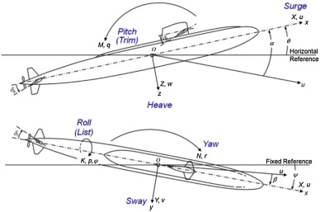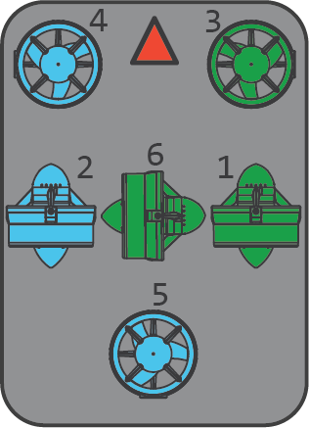

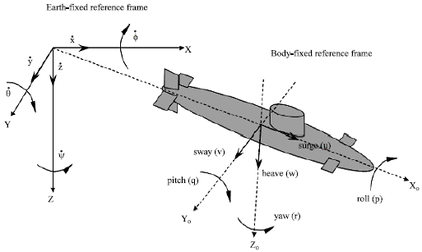

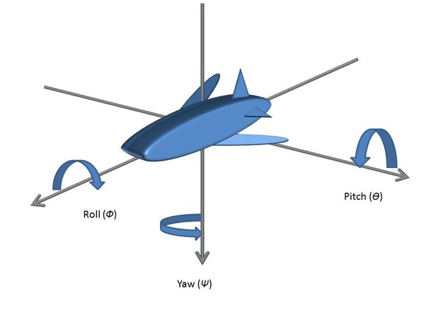

**Descriptions**

**Roll Factor:** The rotation about the x axis in the horizontal direction.

**Pitch Factor:** The rotation, or tilt, about the z axis. This angles the front of the sub to be pointing either up or down.

**Yaw Factor:** The rotation about the y axis which turns the sub to either the left or right direction.

**Throttle Factor:** The value required to let the submarine hover in the water and maintain the altitude. If this is not there the submarine will sink.

**Forward Factor:** The thrust value required to push the sub forward or backwards.

**Lateral Factor:** The push value required to make the sub move from side to side. This is not used in our version.